Bacon Pea Pasta
Notes 8/2023: actually really good, used a little extra cream, needs more salt
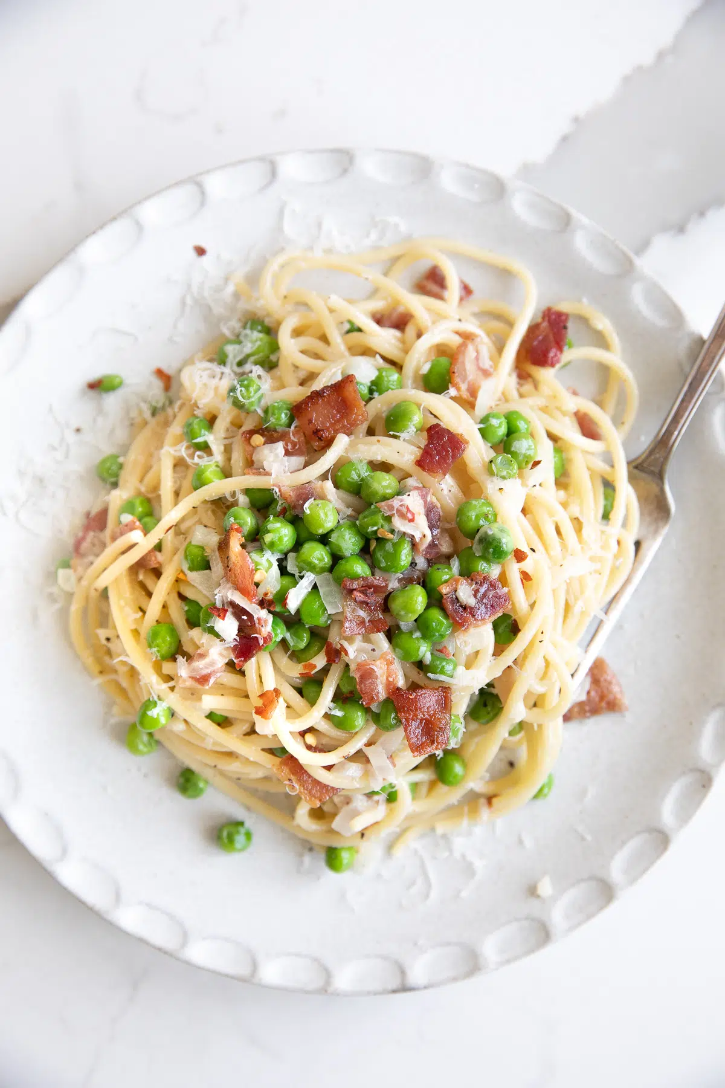

- 8 ounces dry spaghetti noodles
- 12 ounces thick-cut bacon - diced into small pieces
- ½ onion - minced (or 2 shallots)
- 3 cloves garlic - minced
- ½ cup chicken broth
- 1 cup frozen peas
- ¼ cup heavy cream
- ½ cup parmesan cheese - grated
- reserved pasta water - see notes
- salt and black pepper - to taste

INSTRUCTIONS

- Bring a large pot of salted water to a boil (I usually add at least 1 tablespoon of salt) and cook the pasta 1-2 minutes less than the package instructions (or until al dente). Reserve 1 cup of boiling pasta water before draining. Set the pasta aside.
- As the pasta cooks, cook the bacon in a large skillet or Dutch oven set over medium to medium-high heat until it is cooked, crispy, and the fat is rendered. Remove the bacon from the pan using a slotted spoon and drain it on a plate lined with paper towels.
- Set the pan or Dutch oven over medium heat. Cook the onion in the rendered bacon fat until it is soft and translucent, about 5 minutes. Stir in the minced garlic and continue to cook for an additional 1 minute.
- Add the chicken broth and the frozen peas. Cook just until the peas have thawed then stir in the heavy cream (adding more cream for a richer sauce).
- Bring to a gentle simmer and stir in half of the grated parmesan cheese.
- Return the cooked bacon to the sauce and add the cooked pasta. Gently toss to combine. Slowly add some of the reserved pasta water, as needed to thin the sauce.
- Season with additional salt and plenty of freshly cracked black pepper, to taste. Sprinkle with the remaining grated parmesan cheese.

JESSICA’S NOTES
- This recipe can be made with any pasta shape or pasta noodle.
- This recipe is best when it is made with heavy cream. Add more heavy cream to make a heavier, richer, cream sauce.
- The reserved pasta water is already hot, salty, and starchy. Reserve at least one cup and add to the sauce if needed.

